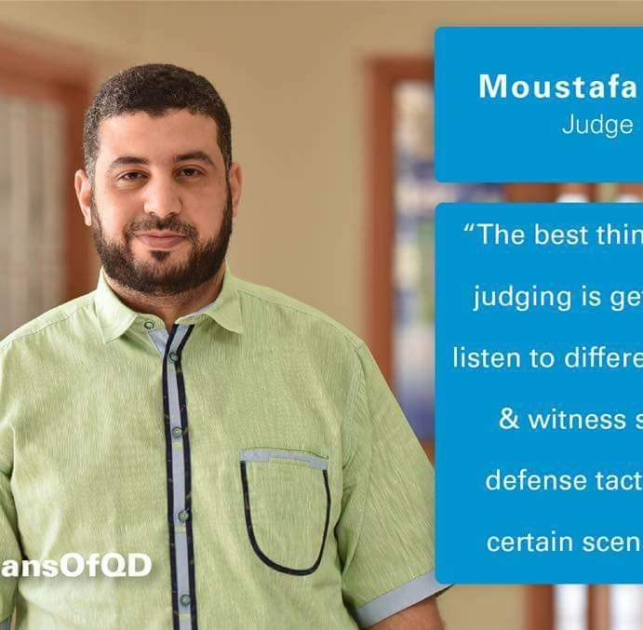
MOUSTAFA ISSA

Bin Omran, Qatar | (C)74742285 │ mr.moustafaissa@gmail.com
Professional Summary
I am an experienced English language teacher with a passion for empowering students through innovative and engaging instruction. With 15 years of experience in teaching, training, and integrating emerging technologies into the classroom, I bring a unique blend of expertise to the field of education. I am deeply committed to creating a stimulating learning environment that fosters student growth and cultivates a lifelong love of language.
My key strengths include:
- Expertise in teaching English language skills to students of all ages and levels.
- Proven ability to develop and implement creative and engaging lesson plans.
- Experience in incorporating emerging technologies into the classroom to enhance student engagement and learning outcomes.
- Adept at fostering a positive, inclusive learning environment promoting student success.
I am eager to contribute my skills and experience to an organization that values innovation and student-centred learning.
Personal Details
Family name : Issa
First name : Moustafa
Date and place of birth : 04/11/ 1985 Egypt
Personal address : Algharafa - Qatar
Personal Tel-Mobil : 00(974)74742285
Nationality : Egyptian
Social Status : Married
Email : mr.moustafaissa@gmail.com
Qualifications
- 2016: A certificate in Entry Level Award in Workplace Hazard Awareness” Entry 3 “, British Safety Council.
- 2016: A certificate in level 1 award in Health and safety in the workplace, British Safety Council.
- 2016: Certified human development trainer, Canadian Centre, Montreal, Canada.
- 2015: CELTA “Certificate in English Language Teaching to Adults”, Cambridge University.
- 2013: The Efficient level certificate in English Curriculum standards, SEC-Qatar.
- 2011: the Entry-level certificate in English Curriculum standards, SEC-Qatar.
- 2008: International Driving License “ICDL”
- 2007: Diploma in Special Education needs “SEN”, Alexandria University, Egypt.
- 2006: Bachelor’s in arts and education, Alexandria University, Egypt.

Work Experience
- From 2017 till today: Global Studies Regional Manager.
- From 2018 till now: Global Studies Egypt, Branch Manager.
- From 2013 till today: English Debate Adjudicator at Qatar Debate Centre “ a member of Qatar Foundation”.
- From 2013 till today: English Debate Coach and coordinator at Ibnkhaldoon Independent Prep. School for boys.
- From 2010 till today: English Language Teacher at Ibn Khaldoun Independent Prep. School for boys in Qatar.
- From 2008 till 2010: English Language Teacher at A preparatory School in Egypt.
Teaching and Educational Skills
- Extensive abilities in classroom management.
- Extensive abilities in e-learning systems.
- Extensive knowledge in dealing with classroom manager sec, Qatar.
- Public speaking Coach.
- Extensive knowledge of coaching and applying Debate in classrooms.
- A member of the committee reviewing the cyber safety learning activities” integrational committee between the SEC and ICT Qatar.
- Hasseen Educational Programme Coordinator, Ibn Khaldoun Independent School for Boys, Qatar.
- The supervisor of “The Academic and Educational Care Programme”, Ibn Khaldoun Independent School for Boys, Qatar.

Professional Development Courses
- “Certified Management Consultant”, Blackburn Institute UK
- “Training of Trainers”, Canadian Centre
- “Motivating Teenagers”, International House Doha
- “Process Writing”, International House Doha
- “Teaching Large Classes”, International House Doha
- “IELTS training of trainers”, British Council, Qatar.
- “SEN” Special Educational Needs Course, British Council, Qatar.
- “Video Telling “Workshop, British Council, Qatar.
- “Debate in Classrooms “Qatar Debate Centre” is a member of Qatar Foundation”, Qatar.
- “Certified Judge” Qatar Debate Centre” a member of Qatar Foundation”, Qatar.
- “Running Debating Clubs” Qatar Debate Centre” a member of Qatar Foundation”, Qatar.
- “Entry-level certificate of English Curriculum Standard” SEC, Qatar.
- “Efficient - Level certificate of English Curriculum Standard” SEC, Qatar.
- “Integrating Teaching and Thinking Skills” Major Centre for Training, Qatar.
- “Cooperative learning Skills” Arab cultural Centre for training, Qatar.
- “Attending the Tech Share Middle East Conference” Four-season Hotel, Qatar.

Achievements

- Winning 1st Place in “the 1st Boys Preparatory Schools English Debate under the supervision of Qatar Debate Centre” 2022-2023.
- Winning 2nd Place in “the Boys Preparatory Schools English Debate League under the supervision of Qatar Debate Centre” 2021-2022.
- Winning 1st Place in “the 1st Boys Preparatory Schools English Debate under the supervision of the Ministry of Education and Higher Education” 2023/2024.
- Winning 1st Place in “the 1st Boys Preparatory Schools English Debate under the supervision of the Ministry of Education and Higher Education” 2022/2023.
- Judging 12 English Debate tournaments for preparatory and secondary stages, Qatar.
- Winning 1st Place in “the 1st Boys Preparatory Schools English Debate under the supervision of the Ministry of Education and Higher Education” 2016.
- Winning 2nd place in “The 1st English Debate Preparatory Schools Tournament 2016- EFL Category” as a Programme Coordinator and coach, Qatar.
- Winning 2nd place in “The 2nd English Debate Preparatory Schools Tournament 2015- Open Category” as a Programme Coordinator and coach, Qatar.
- Winning 1st place in “The 2nd English Debate Preparatory Schools Tournament 2015- EFL Category” as a Programme Coordinator and coach, Qatar.
- Winning 1st place in “The 1st English Debate Preparatory Schools Tournament 2015 - EFL Category” as a Programme Coordinator and coach, Qatar.
- Winning 3rd place in “The English Debate Preparatory Schools Tournament 2014 – EFL Category” as a Programme Coordinator and coach, Qatar.
- Supervising and Coordinating as a representative of the hosting school “The 2nd English Debate Preparatory Schools Tournament 2015”, at Ibn Khaldoun Independent School for Boys.
- Supervising and Coordinating as a representative of the hosting school “The English Debate Preparatory Schools Tournament 2014”, at Ibn Khaldoun Independent School for Boys.
- Coordinating the production of “Hassen” the Educational Programme for Cyber Safety as a representative of Ibn Khaldoun Independent School for Boys, 2014.
- A member of “Revising the Educational Activities Committee” for the Educational program of cyber safety “Haseen”.

Interests
Reading, football, and socializing with friends and family.
Computer Skills
International Computer Driving License” ICDL”
Languages
- English: Excellent spoken, written, and reading.
References
References: Available on request

